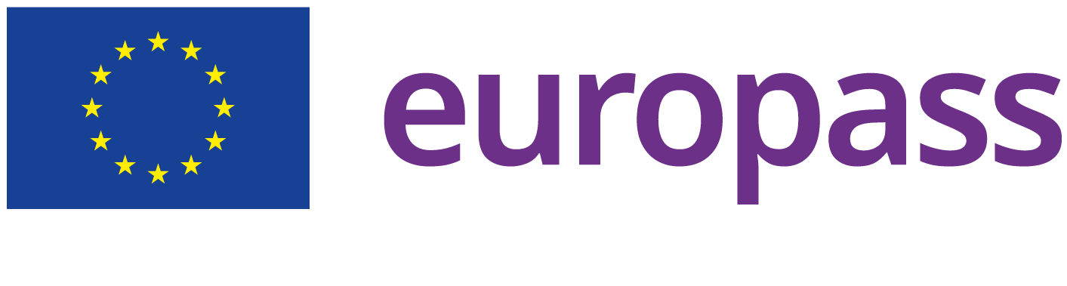

Sitara Khurram

 **Home:** Max Planck Ring 4, ilmenau, Germany

**Email:** [sitarah3126@gmail.com](mailto:sitarah3126@gmail.com) **Phone:** (+49) 15231660760

*  **LinkedIn:** <https://www.linkedin.com/in/sitarah-khurram-3a6b7a214>

**Gender:** Female **Date of birth:** 31 Aug 2000 **Nationality:** Pakistani

# ABOUT ME

An ambitious individual searching for a challenging opportunity as a software engineer to utilize my technical skills for software program development, testing and quality management.

# EDUCATION AND

**TRAINING**

[ 1 Oct 2023 – Current] **MSc Research in Computer & System Engineering**

***Technische Universität Ilmenau*** <https://www.tu-ilmenau.de/>

**Address:** Ilmenau, Germany

[ 30 Dec 2017 – 7 Oct 2021] **BSc Software Engineering**

***University of Lahore*** <https://uol.edu.pk/>

**Address:** Lahore, Pakistan

[ 8 Jan 2016 – 22 Dec 2017] **Higher School Certiﬁcate**

***Federal Board of Intermediate and Secondary Education*** [https://](https://www.fbise.edu.pk/) [www.fbise.edu.pk/](https://www.fbise.edu.pk/)

**Address:** Quetta, Pakistan

[18 Jan 2014 – 15 Dec 2015] **SECONDARY SCHOOL CERTIFICATE**

***Federal Board of Intermediate and Secondary Education*** [https://](https://www.fbise.edu.pk/) [www.fbise.edu.pk/](https://www.fbise.edu.pk/)

**Address:** Quetta, Pakistan

# WORK EXPERIENCE

[ 4 Jan 2021 – 1 Oct 2023] **Junior Software Developer**

***Ultrasoft Systems***

**City:** Quetta

**Country:** Pakistan

***UI/UX Design Skills***

* + - * 1. User Interface (UI) Design
        2. User Experience (UX) Design
        3. Wireframing and Prototyping
        4. Persona and User Flow Creation
        5. Sketching and Visual Design
        6. Responsive Web Design
        7. Mobile App Design

***Mobile App Development Skills:***

1. Mobile App Development Frameworks (e.g., React Native, Flutter)
2. Mobile UI/UX Design
3. App Performance Optimization
4. Mobile-First Design
5. Platform-Specific Development (Android)
6. Knowledge of Mobile App Publishing (App Store, Google Play)

# LANGUAGE SKILLS

**Mother tongue(s):** Urdu

**Other language(s):**

# English

**LISTENING** C2 **READING** C1 **WRITING** C1

**SPOKEN PRODUCTION** B2 **SPOKEN INTERACTION** B2

# German

**A1**

**PROJECTS**

**BSc Final Year Project-CMS (Charity Management System)**

**A web portal for donating leftover food. Tools & Techniques:**

**•Android Studio • Postman • Kotlin**